

LAB EXPERIMENT RECORD

SET 28

Department | Artificial Intelligence and Data Science
Course Code / Course Name | DSA0601 / Data Handling and Visualization
Name / Register Number | ROHAN P T / 192424112
Date / Day | 22/10/2026

Aim
To analyze vehicle performance analysis using the requested visualizations and dashboard views.

Dataset
Vehicle Performance Analysis
Vehicle_ID | Engine_Size | Horsepower | Fuel_Efficiency | Top_Speed | Safety_Rating
V1 | 1.5 | 110 | 18 | 180 | 4
V2 | 2.0 | 150 | 15 | 200 | 5
V3 | 3.0 | 250 | 12 | 250 | 5
V4 | 2.5 | 200 | 14 | 220 | 4
V5 | 1.8 | 130 | 17 | 190 | 3

R Data Setup
Run this setup once before the R programs below. The dataset is defined inline so each record can be copied and run without a separate CSV file.
R data setup
dat <- data.frame(
Vehicle_ID = c("V1", "V2", "V3", "V4", "V5"),
Engine_Size = c(1.5, 2.0, 3.0, 2.5, 1.8),
Horsepower = c(110, 150, 250, 200, 130),
Fuel_Efficiency = c(18, 15, 12, 14, 17),
Top_Speed = c(180, 200, 250, 220, 190),
Safety_Rating = c(4, 5, 5, 4, 3)
)

Additional packages used: ggplot2. Install once with install.packages() if needed.

PROGRAM 1: Fuel Efficiency by Safety Rating
Create a violin plot comparing Fuel_Efficiency across Safety_Rating groups. Describe spread and central tendency.
R code
library(ggplot2)
ggplot(dat, aes(factor(Safety_Rating), Fuel_Efficiency, fill=factor(Safety_Rating))) + geom_violin(trim=FALSE) + geom_boxplot(width=.12) + labs(title="Fuel Efficiency by Safety Rating", x="Safety rating", y="Fuel efficiency (km/L)") + theme_minimal()

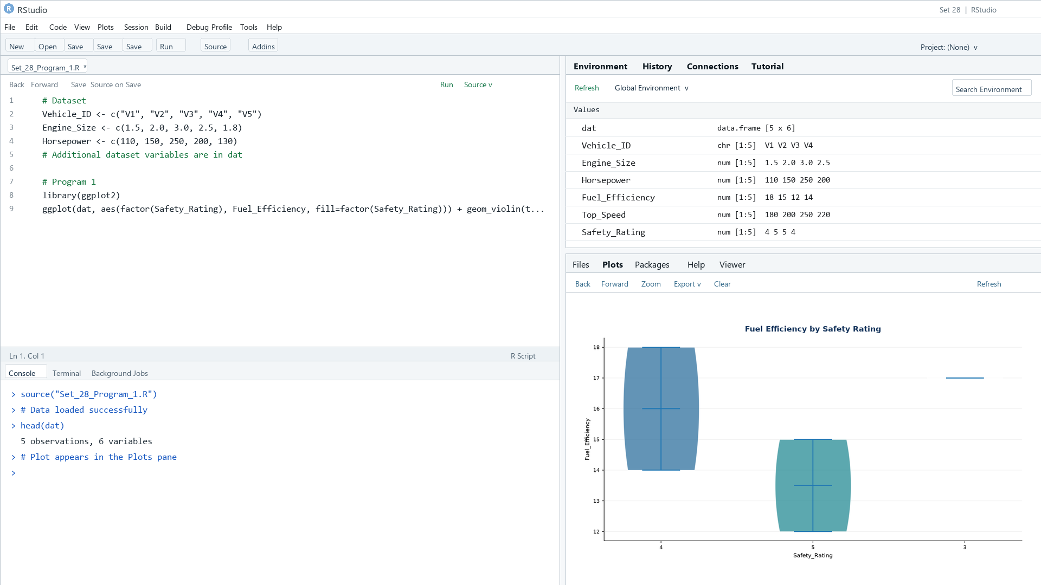
Output 1: Fuel Efficiency by Safety Rating
Observation: Fuel efficiency is highest among the lower engine-size vehicles in this small sample; ratings 3, 4, and 5 have very few observations, limiting distribution comparisons.

PROGRAM 2: Horsepower and Top Speed
Create a scatter plot of Horsepower versus Top_Speed, colored by Engine_Size, and interpret the correlation.
R code
plot(dat$Horsepower, dat$Top_Speed, pch=19, col=as.factor(dat$Engine_Size), xlab="Horsepower", ylab="Top speed (km/h)", main="Horsepower vs Top Speed")
legend("topleft", legend=levels(as.factor(dat$Engine_Size)), col=seq_along(levels(as.factor(dat$Engine_Size))), pch=19, bty="n")

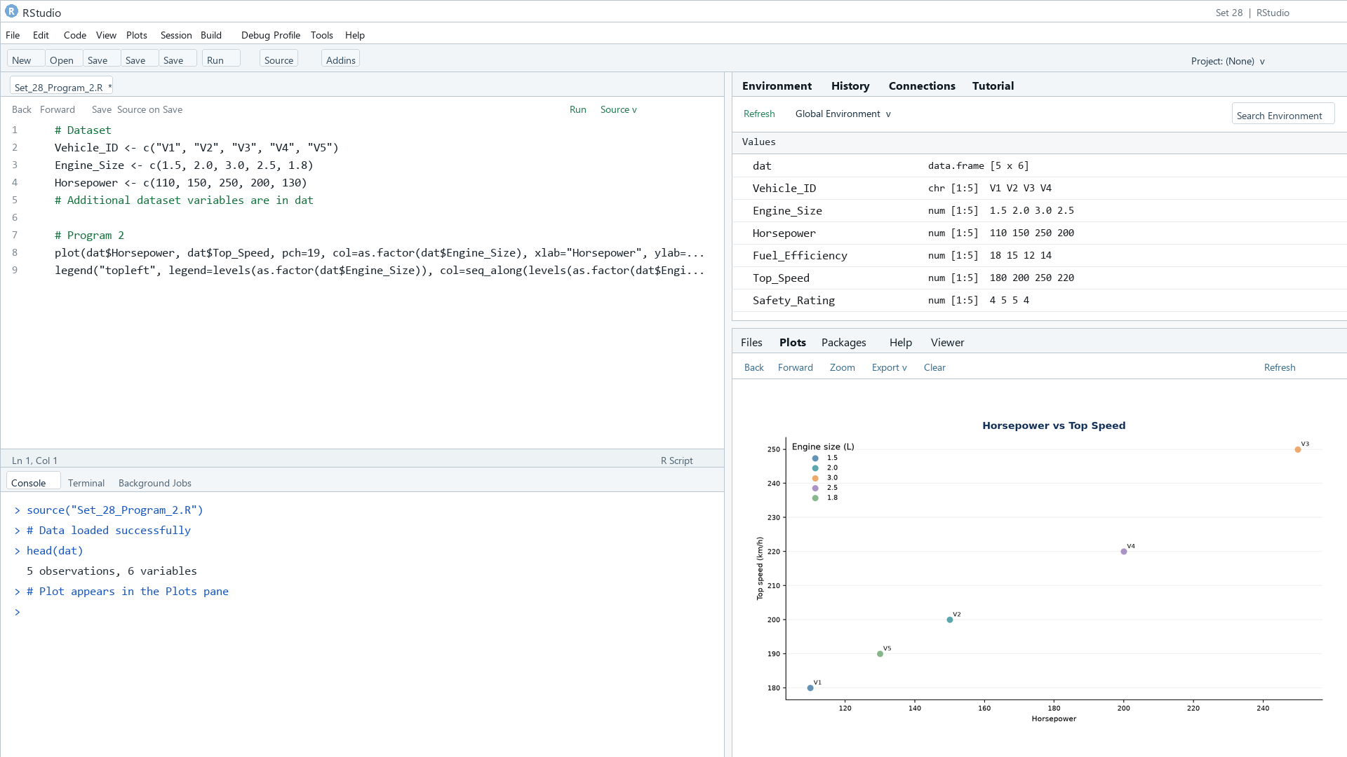
Output 2: Horsepower and Top Speed
Observation: Horsepower and top speed increase together across these five vehicles; engine size also generally increases with both.

PROGRAM 3: Vehicle Correlation Heatmap
Create a correlation heatmap for the numerical vehicle variables and identify variables associated with Top_Speed.
R code
cor_mat <- cor(dat[c("Engine_Size","Horsepower","Fuel_Efficiency","Top_Speed","Safety_Rating")])
heatmap(cor_mat, symm=TRUE, main="Vehicle Variable Correlation Heatmap")

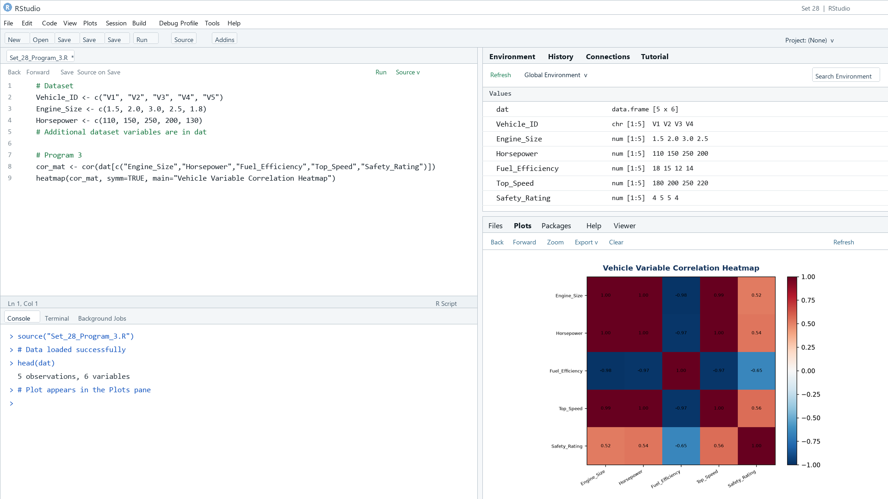
Output 3: Vehicle Correlation Heatmap
Observation: In these five records, Horsepower has a strong positive association with Top_Speed, while Fuel_Efficiency is negatively associated. The estimates are descriptive for this small sample.

PROGRAM 4: Vehicle Performance Dashboard
Build a Tableau dashboard with bar charts and scatter plots and filters for Engine_Size and Safety_Rating.
Tableau build steps
Tableau dashboard build
1. Connect to the vehicle table.
2. Create a bar view of Fuel_Efficiency by Vehicle_ID.
3. Create a scatter plot of Horsepower and Top_Speed, colored by Engine_Size.
4. Add Engine_Size and Safety_Rating filters and combine the sheets on a dashboard.

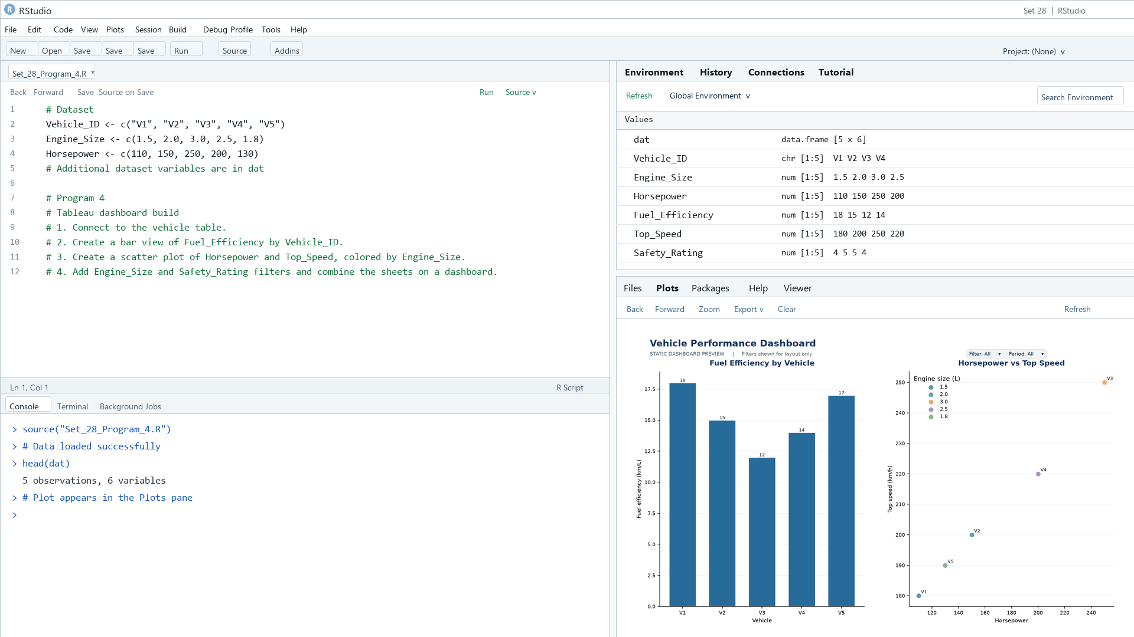
Output 4: Vehicle Performance Dashboard
Observation: The preview compares vehicle efficiency and horsepower-speed performance. Engine_Size and Safety_Rating filters help explore trade-offs.

Procedure
1. Review the dataset table and confirm any illustrative fields noted in the record.
2. Run the R setup block once, then run the requested program code.
3. Compare the output screenshot with the observation and replace illustrative values when actual data is available.
4. For Tableau tasks, connect to the displayed data and follow the dashboard build steps.

Result
The requested charts and dashboard views for Set 28 were prepared from the displayed dataset. Outputs include labels, short observations, and code or dashboard construction steps.

Key Functions Used
plot(), barplot(), hist(), boxplot(), table().

